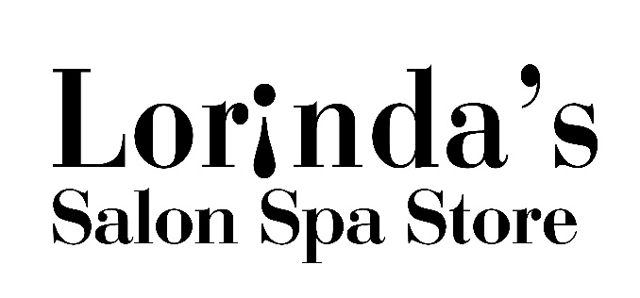
Permanent Makeup Form
Procedure: Eyebrows / Eyeliner / Lips (please circle desired treatment)

Guest Name________________________________________________Date_____________
Guest History
- Are you currently or within the last year under a physician’s care? YES/NO
- Do you take antibiotics when you see a dentist? YES/NO
- List any medications and/or vitamins that you take regularly ____________________________________________
- Are you presently taking any medication that thins the blood? YES/NO
- Do you have any medical conditions? (Please circle the following that were in the past or present)
Allergies Hepatitis Heart Problems Hemophilia Diabetes Skin Problems (Scaring)
Epilepsy Thyroid Eye Problems Moles/freckles at site of tattooing area Other____________
- Are you pregnant or nursing? YES/NO 7. Do you wear Contact Lenses? YES/NO
8. Do you have Eye Lash Extensions? YES/NO 9. Currently using lash/brow growth serum? YES/NO
10. Have you had alcohol or aspirin in the last 24hours? YES/NO

I am over the age of 18, am not under the influence of drugs or alcohol, and desire to receive the indicated permanent cosmetic procedure. The general nature of cosmetic tattooing as well as the specific procedure to be performed has been explained to me. X________ (Initials)

I understand the nature, risks, and possible complications and consequences of permanent skin pigmentation. I understand the permanent skin pigmentation procedure carries with it known and unknown to: Infection, scarring, inconsistent color and spreading, fanning or fading of pigments. Corneal abrasions are a rare sided effect, especially if I rub or scratch my eyes or apply contacts too soon after am eyeliner procedure. I understand the actual color of the pigment may be modified slightly, due to the tone and color of my skin. I fully understand this is a tattoo process and therefore not an exact science, but an art. I request the permanent skin pigmentation procedures and accept the permanence of the procedure as well as the possible complications and consequences of the said procedure(s) X________

There is a possibility of an allergic reaction to pigments. I release the technician from liability if I develop an allergic reaction to the pigment. X________

I understand that if I have skin treatments, laser hair removal, plastic surgery or other skin altering procedures, it may result in adverse changes to my permanent cosmetics. I acknowledge some of these potential adverse changes may not be correctable. X________

I have received pre and post procedure instructions and I will strictly adhere to such instructions. I understand that my failure to do so may jeopardize my chances for a successful procedures. If I am on any medication for depression or any other mood altering prescriptions, I will advise my technician. X________

I understand that the taking of before and after photographs of the said procedure are a condition of such procedures and may be used for internal marketing. X________

In the event that I am unsatisfied with my results, I do hereby relinquish any liability against Lorinda’s Salon Spa Store therefore in regard to said services. X________

For LIP Clients – If I have ever had a cold sore, I will consult with and strictly follow my doctor’s instructions before contemplating any permanent cosmetic procedures around my lips. X________

I understand there are no refunds and accept the full responsibility for permanent cosmetics procedures X________

Clients Signature: ____________________________________________________________ Date:__________________________

